**Lab Manual for Computer Communication and Networking**

**Lab No. 13**

**Access Control Lists(DACL+SACL)**

**BAHRIA UNIVERSITY KARACHI CAMPUS**

**Department of Software Engineering**

**COMPUTER COMMUNICATION AND NETWORKS**

**LAB EXPERIMENT # 13**

Access Control List (ACL)

**OBJECTIVE: -**

* Apply Standard and Extended ACL to permit or deny specific traffic within the network to filter source packets.

**EQUIPMENT: -**

1. Two PC Switch (Cisco 2950)
2. One Router
3. Ethernet cables
4. Four Computers

**THEORY: -**

Numbers between 1 and 99, or any number between 1300 and 1999 can be used in a Standard ACL. The number used in this range doesn't affect how the ACL is processed or which ACL is more important to the router. A standard ACL is concerned with only one factor, the source IP address of the packet. The destination is not considered. From Global Configuration mode, type in:

access-list [access-list-number] [deny/permit] [source-ip-address [ [wildcard mask](http://en.wikipedia.org/wiki/Wildcard_mask)]

Extended IP lists (100-199) test conditions of source and destination addresses, specific/IP protocols and destination ports. It is recommended that place the Extended ACL near the source.

Access-list [list number] [permit | deny] [protocol] [source address] [source-mask] [destination address] [destination-mask] [operator] [port]

**NETWORK TOPOLOGY: -**



**PROCEDURE AND OBSERVATION: -**

**Step 1: Assigning IP addresses on the Router R1 and RIP Config**

R1(config)#interface serial 0

R1(config-if)#ip address 15.0.0.1 255.0.0.0

R1(config-if)#no shutdown

R1(config-if)#clock rate 64000

R1(config-if)#exit

R1(config)#interface ethernet 0

R1(config-if)#ip address 10.0.0.3 255.0.0.0

R1(config-if)#no shutdown

R1(config-if)#exit

R1(config)#router rip

R1(config-router)#network 10.0.0.0

R1(config-router)#network 15.0.0.0

**Step 2: Assigning IP addresses on the Router R2 and RIP Config**

R2(config)#interface serial 0

R2(config-if)#ip address 15.0.0.2 255.0.0.0

R2(config-if)#no shutdown

R2(config-if)#end

R2(config)#interface ethernet 0

R2(config-if)#ip address 20.0.0.3 255.0.0.0

R2(config-if)#no shutdown

R2(config-if)#exit

R2(config)#router rip

R2(config-router)#network 20.0.0.0

R2(config-router)#network 15.0.0.0

**Step 3: Apply Standard ACL on router 2**

**Block single host**

R2(config)#access-list 10 deny host 10.0.0.1

R2(config)#access-list 10 permit any

**Block single network**

R2(config)#access-list 10 deny 10.0.0.0 0.255.255.255

R2(config)#access-list 10 permit any

**Apply the Standard ACL on the Router (R2) Serial Interface**

R2(config)#interface serial 0

R2(config-if)#ip access-group 10 in

R2(config-if)#end

**Step 4: Verifying the Standard ACL from Host ‘1’ by pinging Host ‘3’**

C:\>ping 20.0.0.1

Pinging 20.0.0.1 with 32 bytes of Computer:

Request timed out.

Request timed out.

Request timed out.

Request timed out.

Ping statistics for 20.0.0.1:

Packets: Sent = 4, Received = 0, Lost = 4 (100% loss),

When we will access Host D, we will get the same result as above.

**Step 5: Now remove all ACL and apply Extended ACL on router 1**

R1(config)#access-list 110 deny tcp host 10.0.0.1 host 20.0.0.1 eq www

R1(config)#access-list 110 deny tcp host 10.0.0.2 host 20.0.0.2 eq ftp

R1(config)#access-list 110 permit ip any

R1(config-if)#end

R1(config)#interface Ethernet 0

R1(config-if)#ip access-group 110 in

R1(config-if)#end

**Step 6: Verifying the Standard ACL from Host ‘1’ by pinging Host ‘3’**

C:\>ping 20.0.0.1

Pinging 20.0.0.1 with 32 bytes of Computer:

Request timed out.

**QUESTIONS: -**

1. **Apply standard ACL in given network with the following restriction and configuration, show all necessary configuration in your lab task:**
2. Router 0 and 1 RIP configurations
3. Create access-list 11
4. Deny host PC-0 and PC-4
5. Permit all other network
6. Verify from PC0 to PC5, from PC4 to PC1

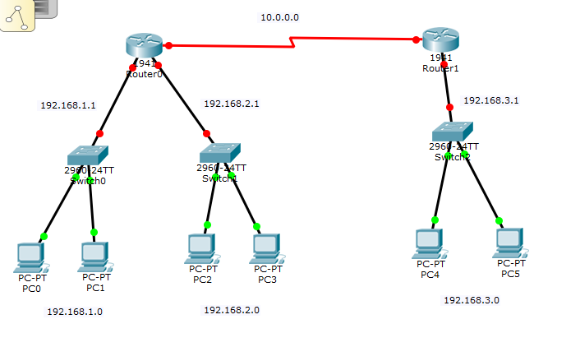

**SOLUTION**

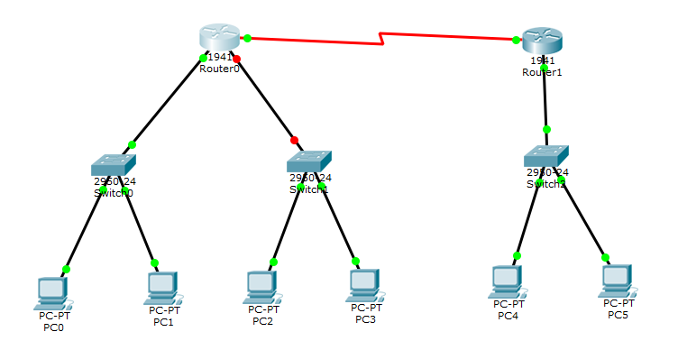

**Router 0:**

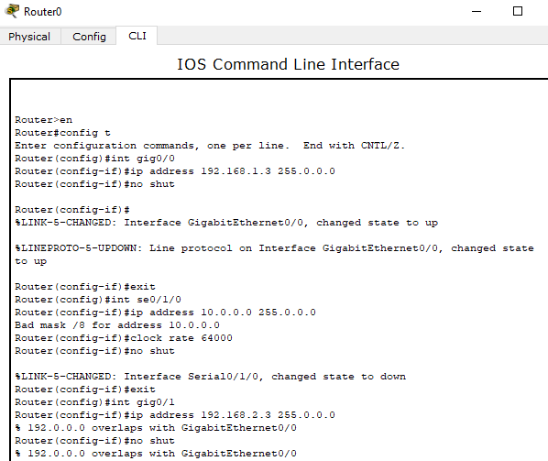

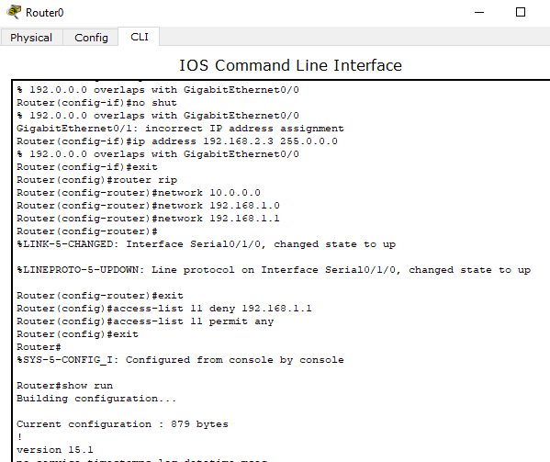

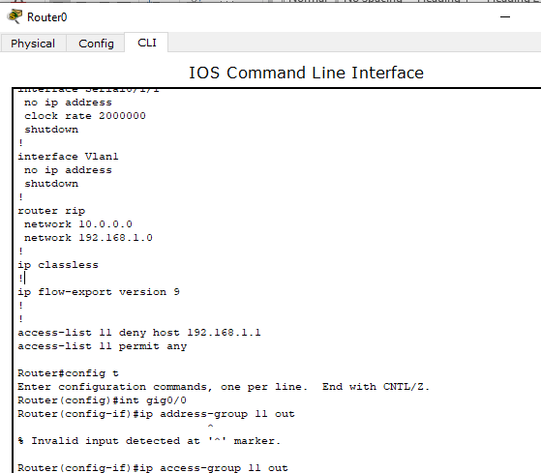

**Router 1:**

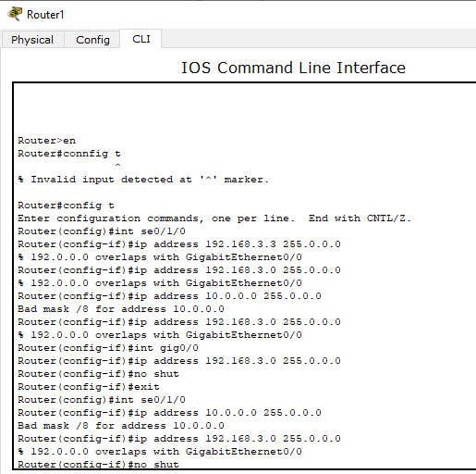

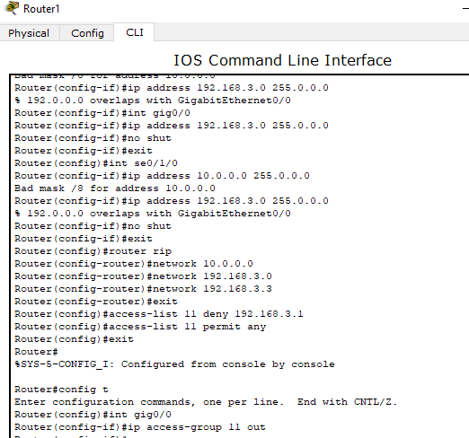

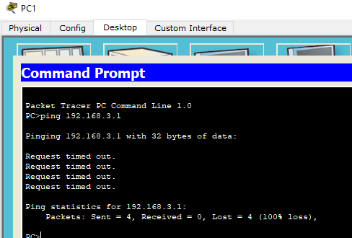

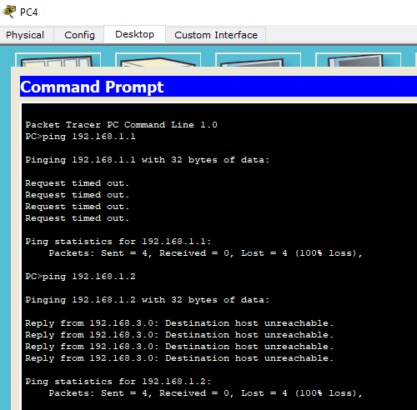

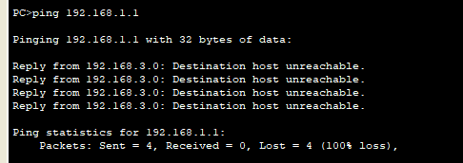

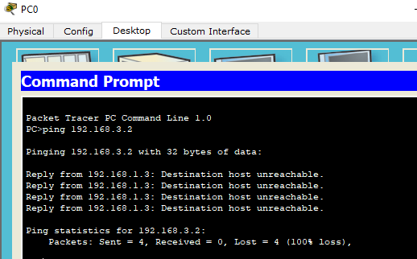

**TIME BOXING:**

|  |  |  |
| --- | --- | --- |
| **Activity Name** | **Activity Time** | **Total Time** |
| **Instruments Allocation + Setting up Lab** | 10 mints | 10 mints |
| **Walk through Theory & Tasks (Lecture)** | 60 mints | 60 mints |
| **Implementation & Practice time** | 90 mints | 80 mints |
| **Evaluation Time** | 20 mints | 20 mints |
|  | Total Duration | 180 mints |

**Teacher Signature**: ________________________

**Student Registration No**: ________________________